CN LAB ESE

Name : Nandini R Gite

P.R.N: 21510066

Batch:S4

Q1.Design network in cisco packet tracer

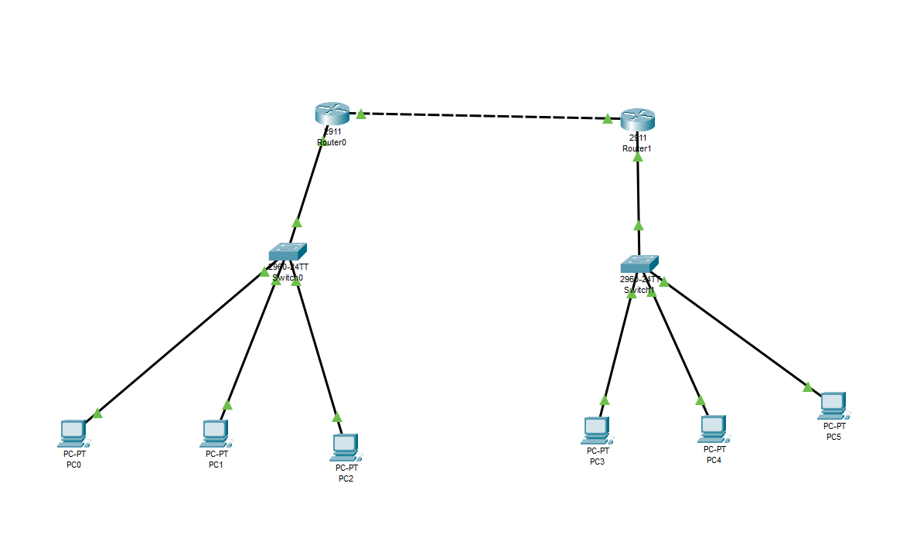

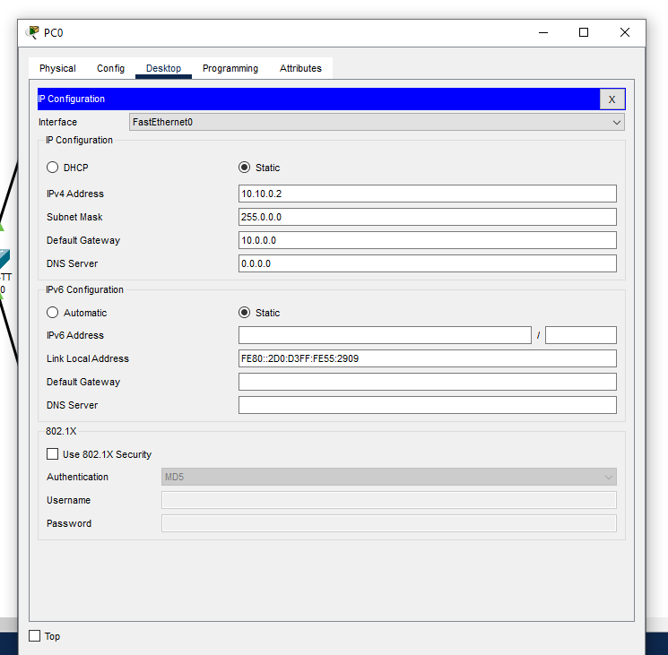

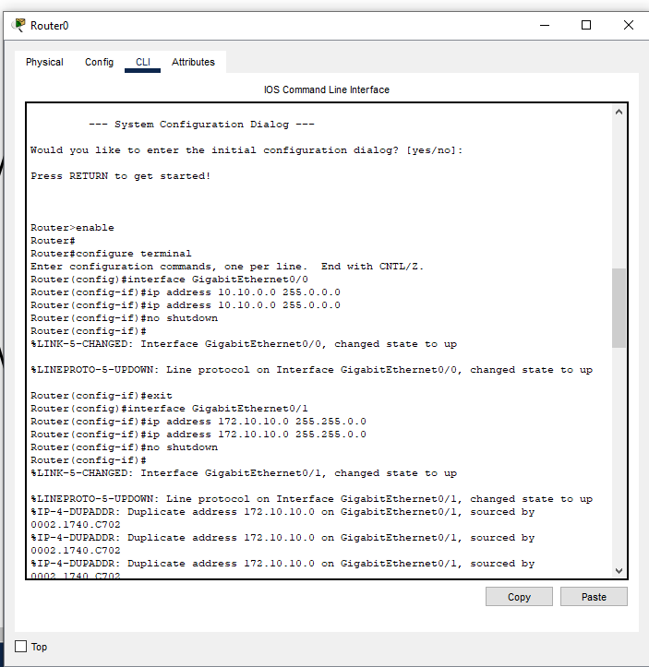

Q2. Execute networking commands

1. To find ip address of computer
2. Display Hostname
3. To check if a host can be accessed
4. Tracroute from host through internet router to destination
5. Find mac address of host
6. Find path of routers to www.google.com.my. What is IP address ?
7. How many hops involved in path?

